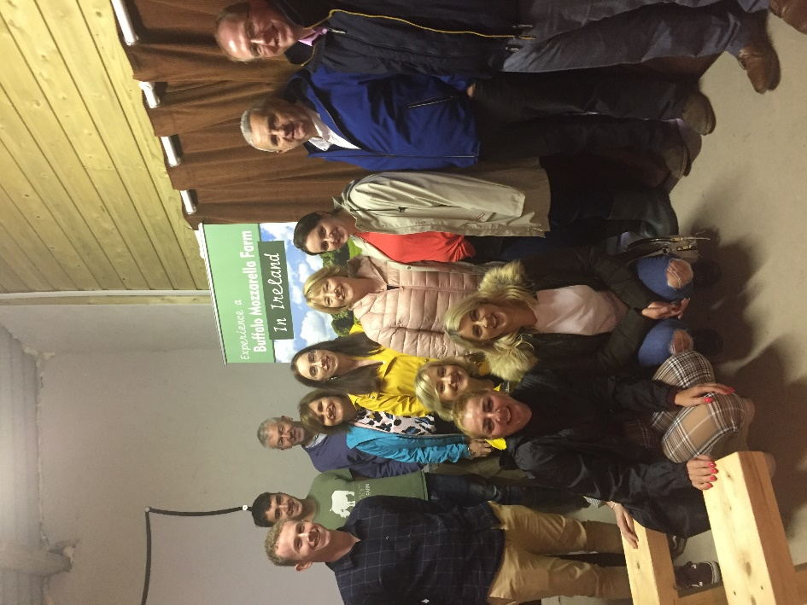
Education, Knowledge-Transfer Discussion groups information.
The Buffalo Farmer Johnny Lynch is passionate about improving his farm's sustainability in terms of Bio-diversity, renewable energy systems and highest modern animal welfare best practice.
We endeavour to provide the following learning outcomes for your tour.
- Research and development of Johnny Lynch’s Macroom Buffalo Farm
which is the 1st in Ireland.
- A day in the life of Irish Water Buffalo farming.
- The origin of Water Buffalo species and animal husbandry.
- Macroom Buffalo Cheese production business on this farm.
- Macroom Buffalo Meat sales and production.

PHOTO : 2019 AIB MACROOM - STAFF EVENING TOUR.
We recommend that groups are of 40 maximum size to ensure best learning outcomes.
The Buffaloes are milked at 7.30am and 4pm so the afternoon time slot is advised for Dairy Farmers and Agricultural College students.
The tour includes a taste of buffalo cheeses with a field-trip study and Q&A session with the farmers can be arranged with prior notice.
Tour times: 10.30am or 2.30 pm
Duration: 2 hrs approx.
Extra: €1 per person for a taste of the Buffalo Meat. Pre-booking is essential.

