ÓTuama Tours Covid 19 Safety Charter Guidelines 2021-22
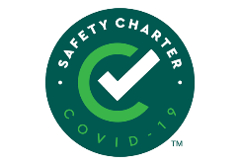

We look forward to welcoming you to Macroom Buffalo Farm.

We are committed to HSE, Government, and the Failte Ireland Covid 19 Safety Charter Guidelines for the health of the farmer’s family, farm and cheese plant staff and visitors alike.

It will be reviewed constantly in line with Government advice and protocol, and we will notify pre-booked guests of any changes.

Walk-Ins cannot be admitted on tours.
Proof of Full Vaccination is advisable when entering as this is private property and a family home.
Please assess your health and others in the group and stay at home if you have any of the symptoms of Covid 19.
Face masks must be worn when in doors in the Scíoból Visitor Centre and Green Barns. Avoid contact greeting, handshakes etc.
We will be reminding you to social distance throughout your tour outside and inside.

We have upgraded our cleaning procedures throughout the tour route and we will be paying attention to high touch areas.
Visitors will need to arrive a minimum of 10 minutes prior to tour time (entry not allowed before this), as we will be on a strict time
schedule to begin the tour and please wait in your transport until the Farm guide meets you.

All food tastings will be provided in single servings for individuals, Pod groups of 6 receive sharing boards, or family Pods receive sharing boards.

